Nathan Choate

Data Structures

Section 003

11/15/16

Assignment 12

1. The algorithms that make use of a priority (i.e. a heap) include A*, Best First Search, and Dijkstra’s Algorithm. The algorithms that use a stack include Depth First Search and Hill Climbing. The only algorithm that uses a regular queue is Breadth First Search.
2. The algorithms that use edge weights/physical distances include A*, Best First Search, Dijkstra’s Algorithm, and Hill Climbing.
3. The only algorithms that can find the shortest path with or without edge weights are Hill Climbing (since it uses a heuristic) and Best First Search (since it uses the cost associated with each vertex.
4. An algorithm with a heuristic will visit significantly less nodes than one that does not use a heuristic, but it might not find an optimal solution every time. But, in most cases, an algorithm that uses a heuristic (for example, Hill Climbing), will visit much less nodes as one that does not (for example, Dijkstra’s Algorithm, Breadth First Search, or Depth First Search, all shown in the figures below). It will generally only visit however many nodes that are absolutely necessary.

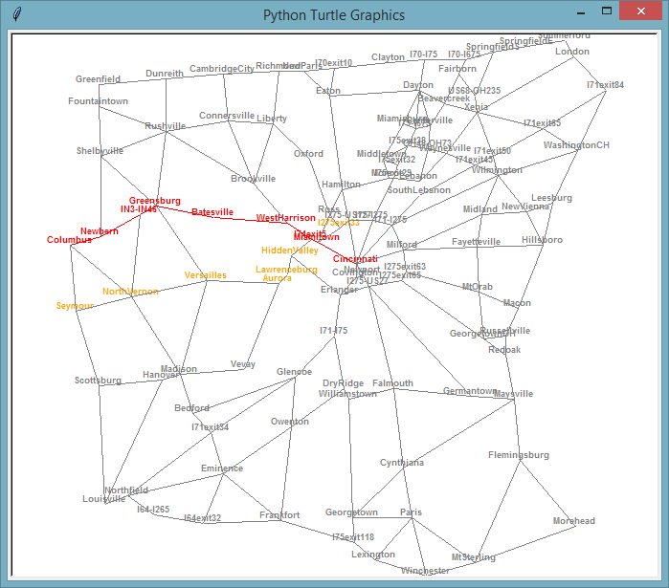

**Figure 1: A* Algorithm for Columbus to Cincinnati**

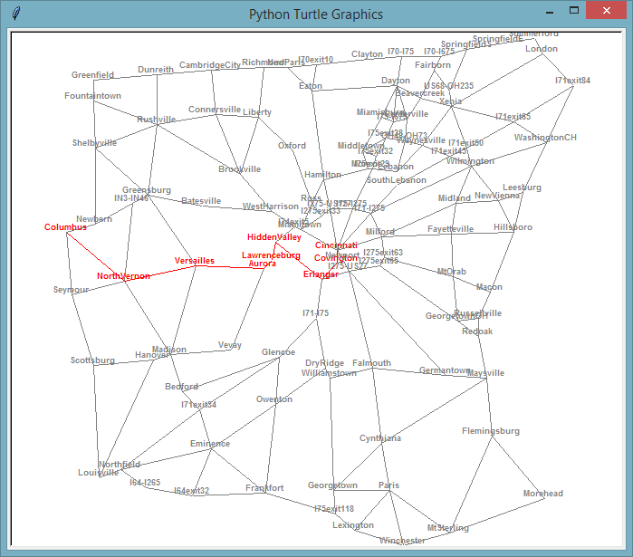

**Figure 2: Best First Search Algorithm for Columbus to Cincinnati**

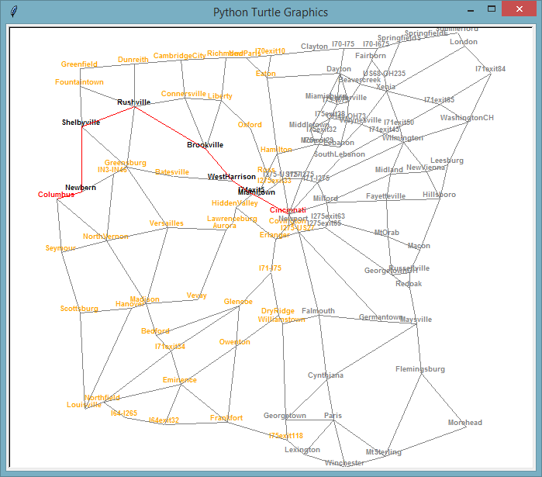

**Figure 3: Breadth First Search for Columbus to Cincinnati**

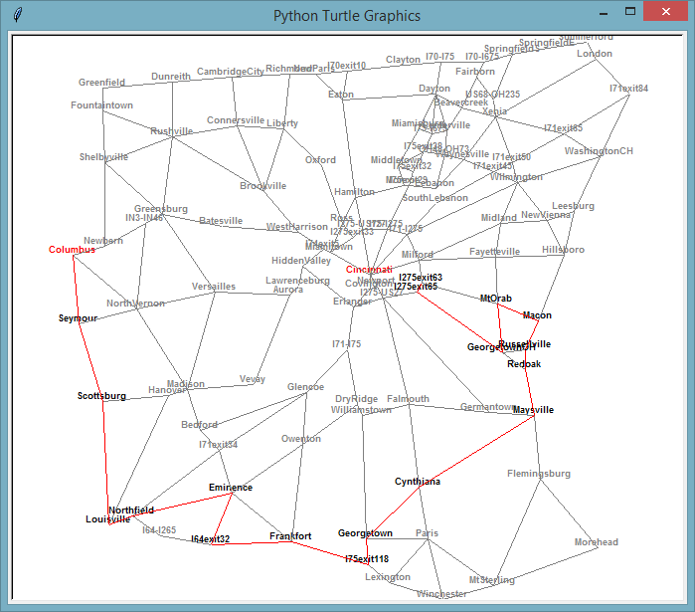

**Figure 4: Depth First Search Algorithm for Cincinnati to Columbus**

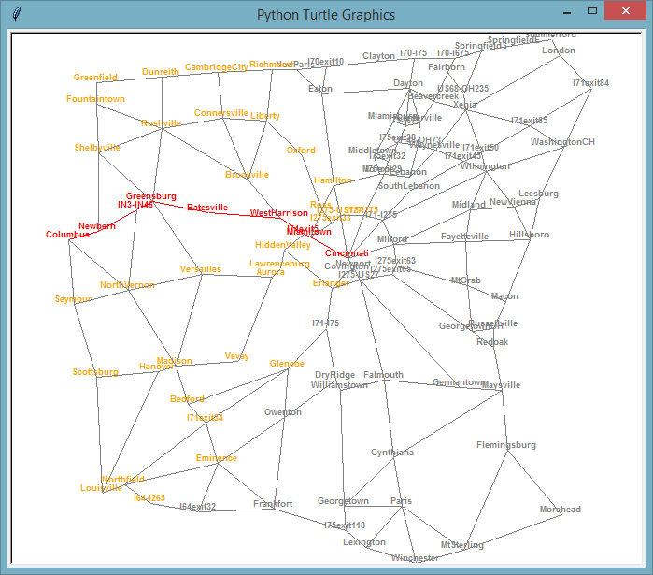

**Figure 5: Dijkstra’s Algorithm for Cincinnati to Columbus**

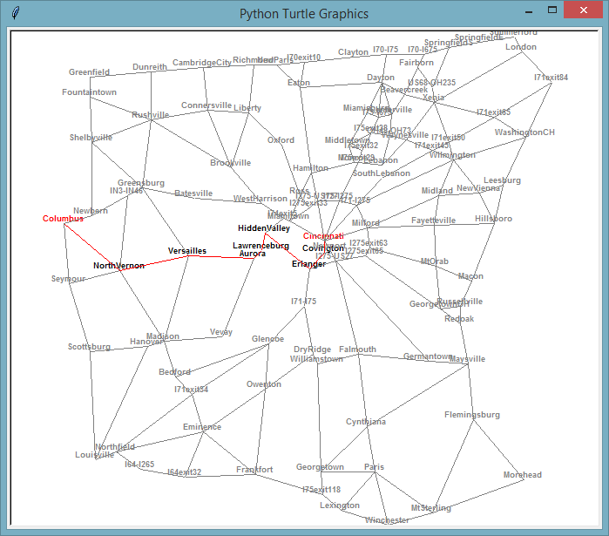

**Figure 6: Hill Climbing Algorithm for Columbus to Cincinnati**